Road Inventory Guide

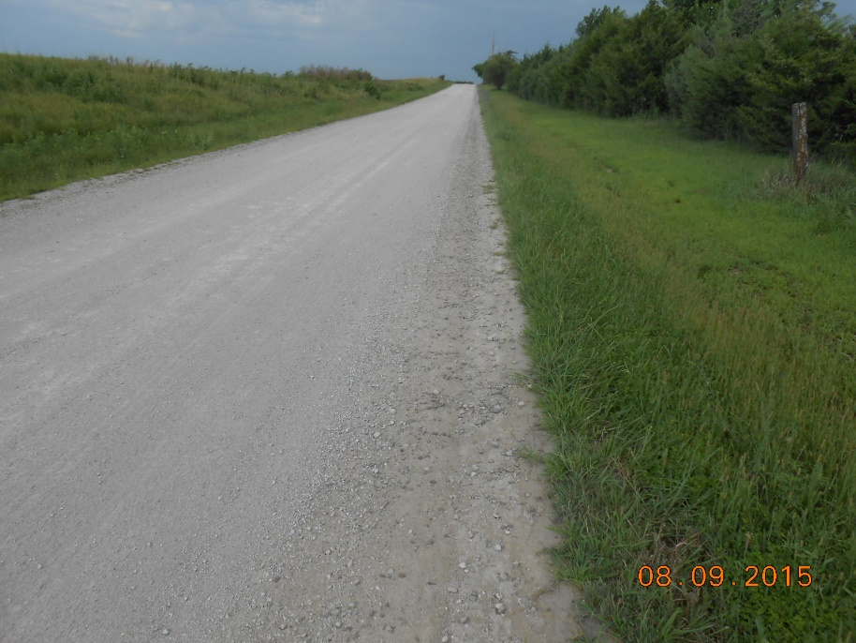

February 2024

Table of Contents
Section 1: Introduction 1
Inventory: 1
Functional Class: 1
Surfacing or Pavement Type: 2
Traffic Volumes: 2
Section 2: Road Inventory Spreadsheet 3
Worksheet Descriptions: 3
Inventory: 3
Summations: 4
Pivot Tables: 4
Definitions: 4
Historical Data 4
Charts: 4
Section 3: Maintaining the Program 5
Section 4: Detailed Descriptions and Instructions 5
Inventory Sheet 5
Summations Sheet 6
Pivot Tables Sheet 6
Definitions Sheet 7
Historical Data Sheet 7
Additional Sheets for Pivot Charts 7

Road Inventory Guide

Section 1: Introduction

This guide describes and explains the road inventory MS Excel spreadsheet developed for rural Kansas county road systems. The spreadsheet is a convenient way to collect, tabulate, and report road inventory information and road conditions. This information is critical for properly managing county roadways. The information can be tracked through time to assess changing road inventories and conditions compared with budgets and expenditures. In addition to road department management, it is a useful tool for reporting to Boards of County Commissioners and to KDOT. KDOT uses county road inventory and condition information to determine needs and lobby for county road funding. Section 2 describes the software and explains how to use the software and keep the data current. Section 3 describes updating the data. Section 4 includes detailed descriptions and instructions for the spreadsheet.

Inventory:
To properly manage the road network, an inventory of roads and their current conditions as well as historical information are important. In simple terms, it is important to know what you have. To manage the inventory data, the road system is divided into sections. A particular road section should have the same surfacing type and structure, uniform geometry, and similar traffic type and volumes. Sections should begin and end where the surfacing type, structure, or traffic characteristics change.

The condition of each road section is assigned a letter grade, A, B, C, D, or F, like the grading system used by schools. If a road section’s pavement has been rated according to the PASER system, the PASER rating can be entered in a separate column. In addition to the surfacing type and condition, other road characteristics are assessed and entered into the Inventory sheet. The sheet includes columns for various metrics like right-of-way width, structural adequacy, roadside safety, roadside slopes, drainage conditions, Annual Average Daily Traffic, shoulders, ditch width, etc. The more information gathered and entered, the better.

Functional Class:
Each road section is assigned a Functional Class as approved by KDOT and FHWA and described in the table below. Each county’s approved functional classification map (FCM) is available on the KDOT website.

Minor Arterial | Minor Arterial , if any, as shown on FCM approved by KDOT and FHWA.
Major Collector | Major Collector as shown on the county's FCM approved by KDOT and FHWA
Minor Collector | Minor Collector as shown on the county's FCM approved by KDOT and FHWA
Local | Other section line or similar road not a Major or Minor Collector as shown on the county’s FCM approved by KDOT and FHWA

Surfacing or Pavement Type:
Surfacing type is entered for each road section. The following table lists the various surfacing types typically found on county roads.

Surface or Pavement Type | Abbreviation | Description
Bituminous | Bit | Broad category consisting of following: 1. Chip seal on rock base. 2. Thin overlay on base or existing chip seal road. 3. Older roads with buildup of chip seals and patch material over gravel or rock base. Also, included in this category are roads with less than 2" hot mix over a base or less than 6” hot mix with no base.
Bituminous with overlay | Bit+2 | Bituminous with hot mix overlay of at least 2". Does not include 2" or less hotmix over a rock base, which is a Bituminous road.
Hot mix asphalt | HM | Full depth hot mix asphalt 6” or more deep. Hot mix 4" or more deep over chip seal road or base. Could have a chip seal surface.
Concrete | Conc | Full depth concrete
Hot mix on concrete | HM/Conc | Hot mix asphalt overlay on concrete
Crushed Gravel | CG | Crushed limestone from quarry
Extracted Rock | XR | Rock extracted by county and processed on the road
River Gravel | RG | Natural gravel
Sand | S | Natural sand
Sand/Gravel Mix | S/G | Mix of natural sand and crushed or extracted gravel
Asphalt Millings | Mlgs | Crushed and processed recycled asphalt pavement
Asphalt Millings mixed with gravel and/or sand | Mix | Asphalt millings mixed with sand, crushed gravel, or extracted rock
Unsurfaced | Un | Unsurfaced dirt road

Traffic Volumes:
Traffic volumes are from traffic counts obtained by the county or from the latest traffic volume data shown on KDOT District maps. Lacking any traffic count data, estimated traffic volumes and truck percentages can be entered. The most accurate and recent count should be entered, if available, but a well-reasoned estimate of traffic and truck counts is better than nothing.

Right-of-Way Width:
County road right-of-way widths typically vary according to the grading section required to include the ditches and drainage structures. The intent is to record a nominal right-of-way width while recognizing there may be portions that vary in width. For example, if the road was created with a 60’ right-of-way width, but portions have wider widths to accommodate culvert replacement projects, record the 60’ predominant width.

Surface Condition:
Surface condition is assessed by entering a letter grade, as follows:
Condition | Abbreviation
Excellent | A
Good | B
Fair | C
Poor | D
Failed | F
The Definitions sheet in the spreadsheet program includes detailed descriptions to guide the user in assigning the appropriate grade.

Other Metrics:
Structural Adequacy, Drainage, Horizontal and Vertical Alignment, Cross-Section Geometry, and Roadside Safety are assigned a simple Good, Fair, Poor rating, as follows:
Condition | Abbreviation
Good | G
Fair | F
Poor | P

Section 2: Road Inventory Spreadsheet

General
This section includes general descriptions of the sheets in the Road Inventory spreadsheet program. More detailed instructions and explanations for each sheet are included in Section 4.

The road inventory software is simply an MS Excel spreadsheet used to inventory and track various metrics for road sections maintained by the County. The user can modify the spreadsheet to better fit their county road network. The intent is provide the user with a convenient way to gather and report road inventory information.

Worksheet Descriptions:

Inventory: This worksheet contains the physical inventory and condition data for each section of road maintained by the county. Each horizontal row is a specific section of road, and each column is a particular type of data. Any change to a section of road will be made on this worksheet. The most common change will be a change in the condition rating. This worksheet should be modified on an annual or regular basis to update road inventory data. The Inventory sheet is set up as a Table. This allows the user to sort all the data by clicking on the header of a particular column. For example, clicking on the Surfacing Type column header groups similar surface types and sorts all the associated data for each pavement section.

The road system is divided into sections. Each road section is assigned a unique identifying number called a section number. This provides a convenient way to refer to specific road sections when discussing the inventory with staff. A particular section should have uniform physical characteristics and traffic. Sections begin and end where the width, shoulders, surfacing type/structure, and traffic characteristics change, or at major intersections and at intersections with state highways and interchanges. The sections also begin and end at city boundaries, street name changes, and may change at feedlots, quarries, and other major traffic generators. There is no maximum or minimum section length if the road characteristics are consistent throughout the section.

For uniformity it is best to describe the beginning and ending points from south to north and east to west. That way the beginning point of a section is always the south or west end of the section and the ending point is always the north or east end of the section. If there is a jog in the road and the street name changes it is usually appropriate to make a new section for the jog but assign the section number of the jog in order as traveling on the road.

Summations: The Summations worksheet is for displaying totals of various data obtained from the Inventory worksheet. No data should be entered in this worksheet as it could override any updated data on the Inventory sheet. The Summations sheet contains two pre-constructed tables that automatically tally surface type and condition data from the Inventory sheet. The user can add other tables, as desired.

Pivot Tables: The Pivot Tables sheet is provided as a place for any pivot tables the user desires. Pivot tables are a convenient way to display data from the Inventory sheet in almost unlimited ways. Data should not be entered on this worksheet, as the information is pulled from the Inventory sheet. Several pre-made pivot tables are included, but the user can delete or add pivot tables, as desired. Anyone that is competent in Excel should be able to make the modifications.

Definitions: This worksheet lists the definitions and abbreviations used in the spreadsheet. This sheet also includes detailed descriptions to aid the user in assigning condition ratings.

Historical Data: This worksheet is for the purpose of keeping historical records that are important to understand the road maintenance program and how it has changed over the years. This worksheet requires data to be entered manually. The data to be entered is the road budget, unit costs of material, work costs, overall road conditions, and summary of work accomplished. Most of the annual data is a duplicate of data on the County Engineers Annual Report that the county is required to submit to KDOT.

Charts: Various charts can display data from the Inventory sheet graphically. The data is obtained from the road inventory through the Inventory and Pivot Tables sheets. These charts are standard Excel charts and can be cut and pasted into other software programs. Various chart types are available, e.g., pie charts, bar charts, graphs, etc. Charts are updated when data in the Pivot Tables is refreshed. The charts can be easily modified by people familiar with Excel. Provided charts include Surface Type Mileage, and Miles of Surfacing Type by Condition. The user can display charts as desired by adding or modifying pivot tables on the Pivot Tables sheet.

Section 3: Maintaining the Program

The inventory data and costs records need to be kept current for the inventory system to be of maximum use. The major items that need to be updated annually are as follows:
- Road inventory changes
- Rehabilitation for the year
- Condition rating
- Surfacing type/structure
- Costs
- Budget records

The road inventory should be updated when new roads are added or the physical measurements or surfacing type change on an existing road.
- A new road is added as a new row in the inventory.
- Change surfacing type. This would most often be changing a gravel road to a Bituminous road, a Bituminous road to Bituminous +2, or a Bituminous +2 to hot mix when the road is overlaid.
- On completely reconstructed roads update the construction date and physical data such as pavement type and width.

Section 4: Detailed Descriptions and Instructions

- Inventory Sheet
The Inventory Sheet is the first page of the spreadsheet. All inventory data is entered on this sheet. Subsequent sheets use data from the Inventory Sheet.
Note: See “Definitions” sheet for definitions, abbreviations, and explanations for entering data in the Inventory Sheet.

Enter Data
Column A: Assign a sequential section number for each road section, starting with 1
Column B: Road Name
Column C: Starting point
Column D: Ending point
Column E: Length in miles
Column F: Nominal width in feet
Column G: Surfacing type
Column H: For unpaved road sections, enter “Y” if stabilized, “N” if unstabilized
Column I: General surface condition (A, B, C, D, F)
Column J: Enter PASER condition rating, if known
Column K: If shoulder is present, enter surfacing type
Column L: If shoulder is present, enter shoulder width
Column M: Enter nominal right-of-way width for the majority of the road section
Column N: Enter functional class (Major Collector, Minor Collector, etc.)
Column O: Enter Average Annual Daily Traffic, if known
Column P: Enter percentage of trucks, if known
Column Q: Enter judgment of structural capacity (Good-Fair-Poor)
Column R: Enter judgment of drainage condition (Good-Fair-Poor)
Column S: Enter drainage type (Open Ditch, Storm Sewer)
Column T: Enter nominal ditch width
Column U: Enter “Y” if curb is present, “N” if not present
Column V: Enter judgment of Cross Section Geometry (Good-Fair-Poor)
Column W: Enter judgment of Horizontal Alignment (Good-Fair-Poor)
Column X: Enter judgment of Vertical Alignment (Good-Fair-Poor)
Column Y: Foreslope - Enter nominal Horizontal distance for each 1-foot vertical fall (e.g., Enter “3” for 3:1 slope)
Column Z: Backslope - Enter nominal Horizontal distance for each 1-foot vertical fall (e.g., Enter “2” for 2:1 slope)
Column AA: Enter “Y” if centerline pavement markings are in place, “N” if no centerline markings
Column AB: Enter “Y” if edge line pavement markings are in place, “N” if no edge line markings
Column AC: Enter judgment (Yes, No) of whether road segment meets standards for roadside safety

Notes for Inventory Sheet
- See “Definitions” sheet (Sheet 4) for definitions, abbreviations, and explanations for entering data in the Inventory Sheet.
- Columns may be added, removed, or renamed to suit each county’s road network.
- The Inventory Sheet is set up as a Table in Excel. This allows the user to sort the data as desired by clicking on the down arrow at the top of each column. For example, the data can be sorted to group all roads having same surface type, then further sorted as to general condition. As another example, the data can be sorted to group all Major Collector roads by surface type, general condition, and structural adequacy.
- The table is set to accommodate up to 200 road sections. This can be expanded, if necessary.

- Summations Sheet
This sheet is provided to allow the user to display data summations as desired. Two possible summations are provided in two tables, but these can be revised or deleted. Data in these two tables are automatically gathered from the Inventory sheet. Additional or revised tables created by the user can either be set up to automatically gather data from the Inventory sheet, or the Inventory sheet can be sorted as desired and summations taken from the Inventory sheet by clicking on a column header, then highlighting the values and seeing the sum along the bottom bar of the spreadsheet. For example, click on the Functional Class column header to sort the roads by functional class. Then, highlight the mileage in the Length column and see the total length of roads with that functional classification shown along the bottom bar.

- Pivot Tables Sheet
This sheet is provided as a place for any desired pivot tables. In Excel, pivot tables allow the user to display data from the Inventory Sheet in almost unlimited ways. For example, a pivot table can easily be created to show surface type, surface condition, drainage condition, etc., for each roadway classification. The data can be shown in a table and then exhibited as a chart, e.g., a bar chart or a pie chart.
Pivot tables are already provided to display the following:
  - Miles of each Surfacing Type by Condition rating
  - Miles of each Functional Class by Condition rating
  - Miles of each Surfacing Type
  - Miles of Bituminous surfaces by Condition rating
  - Miles of Bituminous+2 surfaces by Condition rating
  - Miles of Crushed Gravel surfaces by Condition rating
  - Miles of Hot Mix surfaces by Condition rating
  - Miles of Mixed surface types by Condition rating
  - Miles of Sand surfaces by Condition rating
After data is entered in the Inventory sheet, right click on the header of each Pivot Table, and select ‘Refresh’ from the pull-down menu. Likewise, as data is added or revised on the Inventory sheet, right click on the header of each Pivot Table and select ‘Refresh’ from the pull-down menu to refresh the Pivot Table.
Pivot Tables can be set up to show data as desired by the user with a basic knowledge of MS Excel. The provided Pivot Tables can be deleted, and new tables created, if desired.

- Definitions Sheet
This sheet contains definitions of terms and abbreviations to be used for entering data into the Inventory Sheet.

- Historical Data Sheet
This sheet is provided to track various metrics if so desired. It is a convenient way to track costs and quantities over several years to identify trends. Data from this sheet can be entered into the County Engineers Report for submission to KDOT.

- Additional sheets for Pivot Charts
Additional sheets are provided to display Pivot Charts from data in the Pivot Tables. Several sheets are provided showing pie charts of various metrics. The provided Pivot Charts can be deleted and/or additional charts can be created by the user, as desired.

